**AWS 101 API Gateway: Monitoring API Execution using AWS Cloudwatch**

*Posted On December 12, 2018*

**API Gateway Metrics**

The metrics that API Gateway sends to Amazon Cloudwatch are:-  
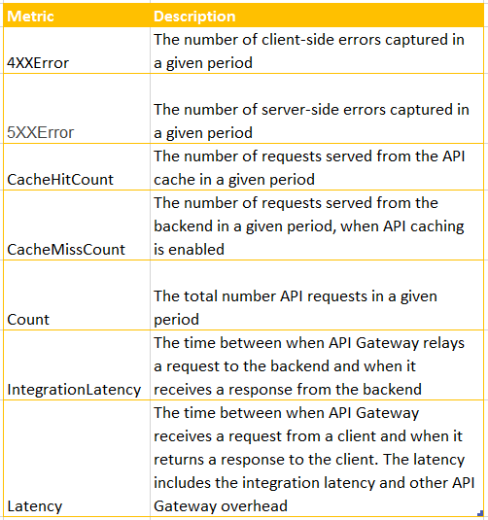

**API Gateway Dimensions**

The dimensions that can be used to filter API Metrics are shown in table  
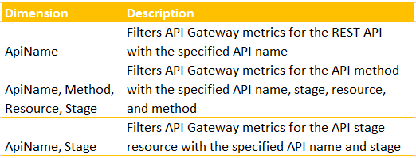

**View CloudWatch Metrics with the API Dashboard in AWS Console**

You can view API Dashboard in the API Gateway Console to view the CloudWatch metrics of your deployed API in API Gateway.  
  
A prerequisite before viewing dashboard is to have an API created in API Gateway and also have API deployed at least once.  
1. Sign in to console API Gateway console at <https://console.aws.amazon.com/apigateway> .  
2. Select API name.  
  
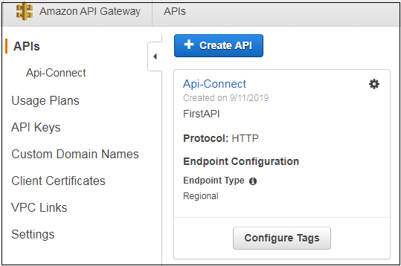  
  
3. Under selected API, find Dashboard, under Stage you can choose desired stage to view several Metrics.  
  
4. You can also select For and To date to get date range data.  
